Resume Project

Davian Perez-Silva

<https://github.com/daviirose/perezsilva-resume>

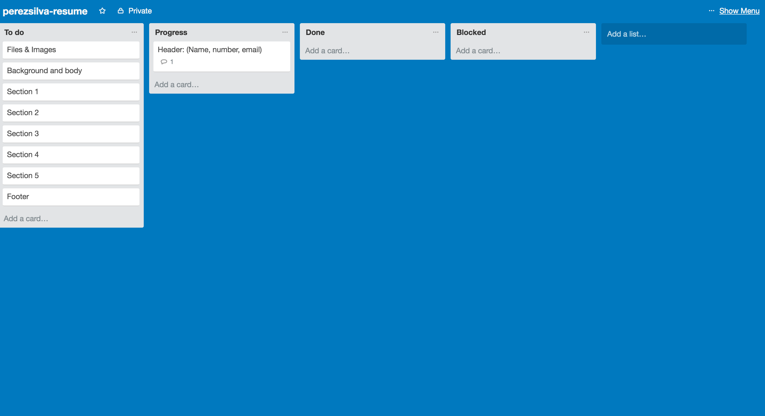

In this image in trello, I started my to-do list and began my headers layout. I added the skeleton of the header and most of the content such as my name and my contact info.

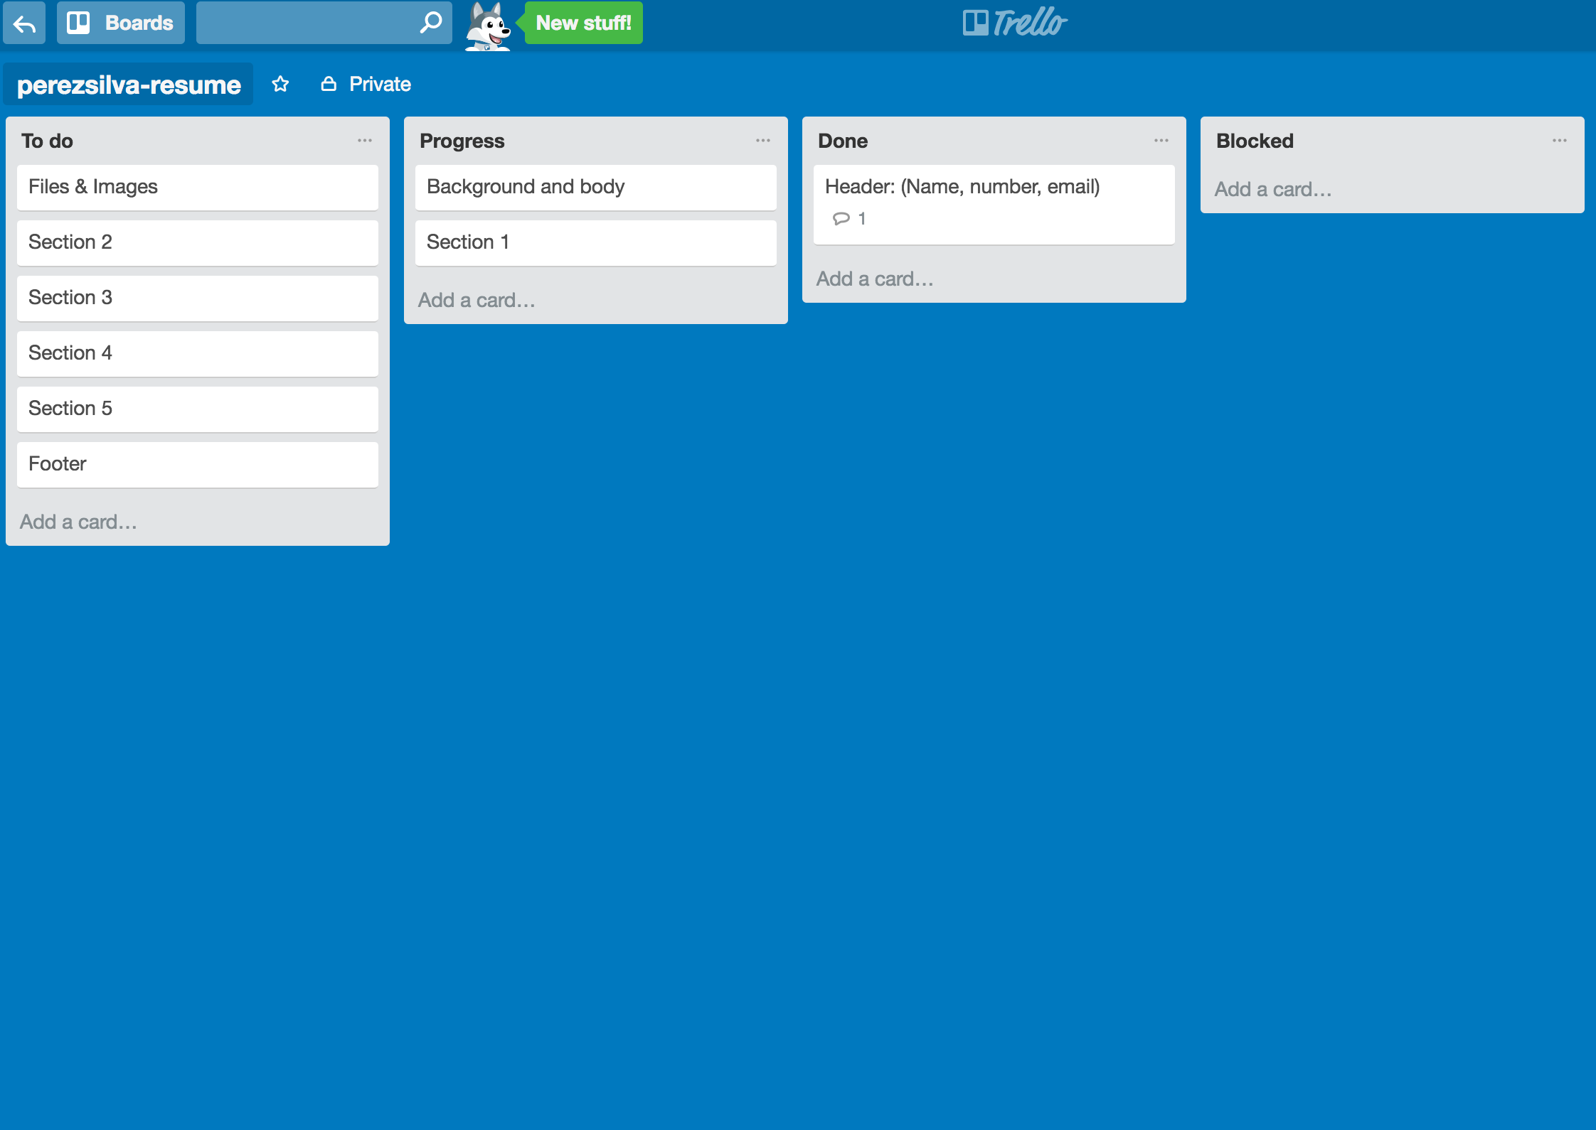

This image shows that I started looking for a background image or color and started section one of the resume. It also shows that I finished my header.

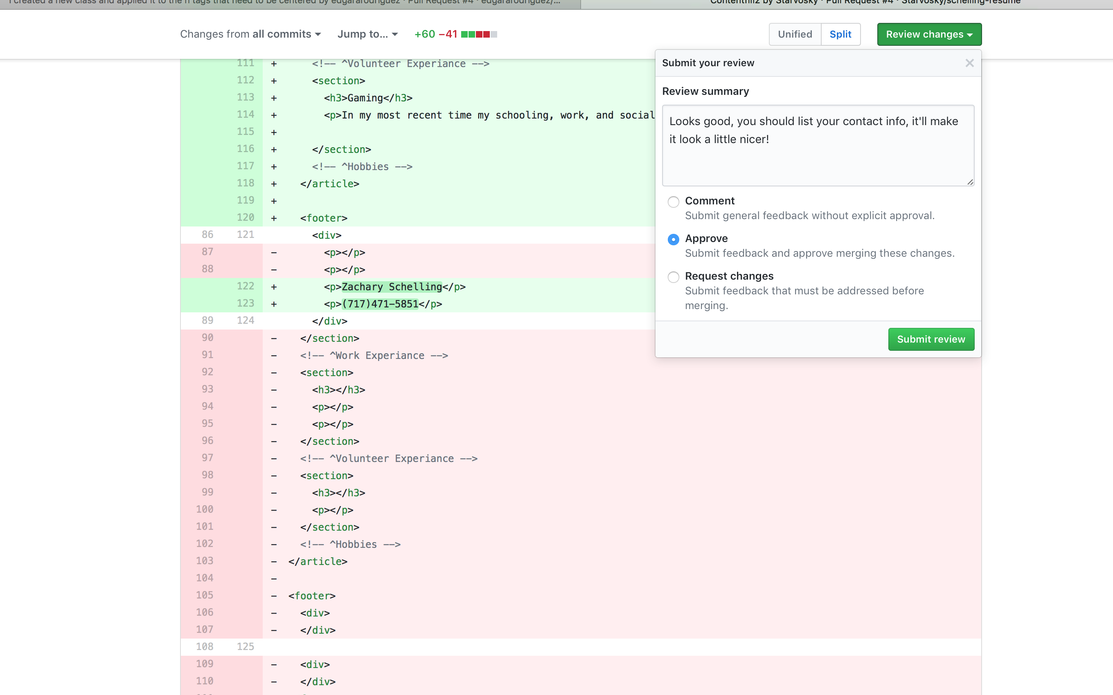

My first review was really simple, I recommended a list tag to better organized his info on the resume.

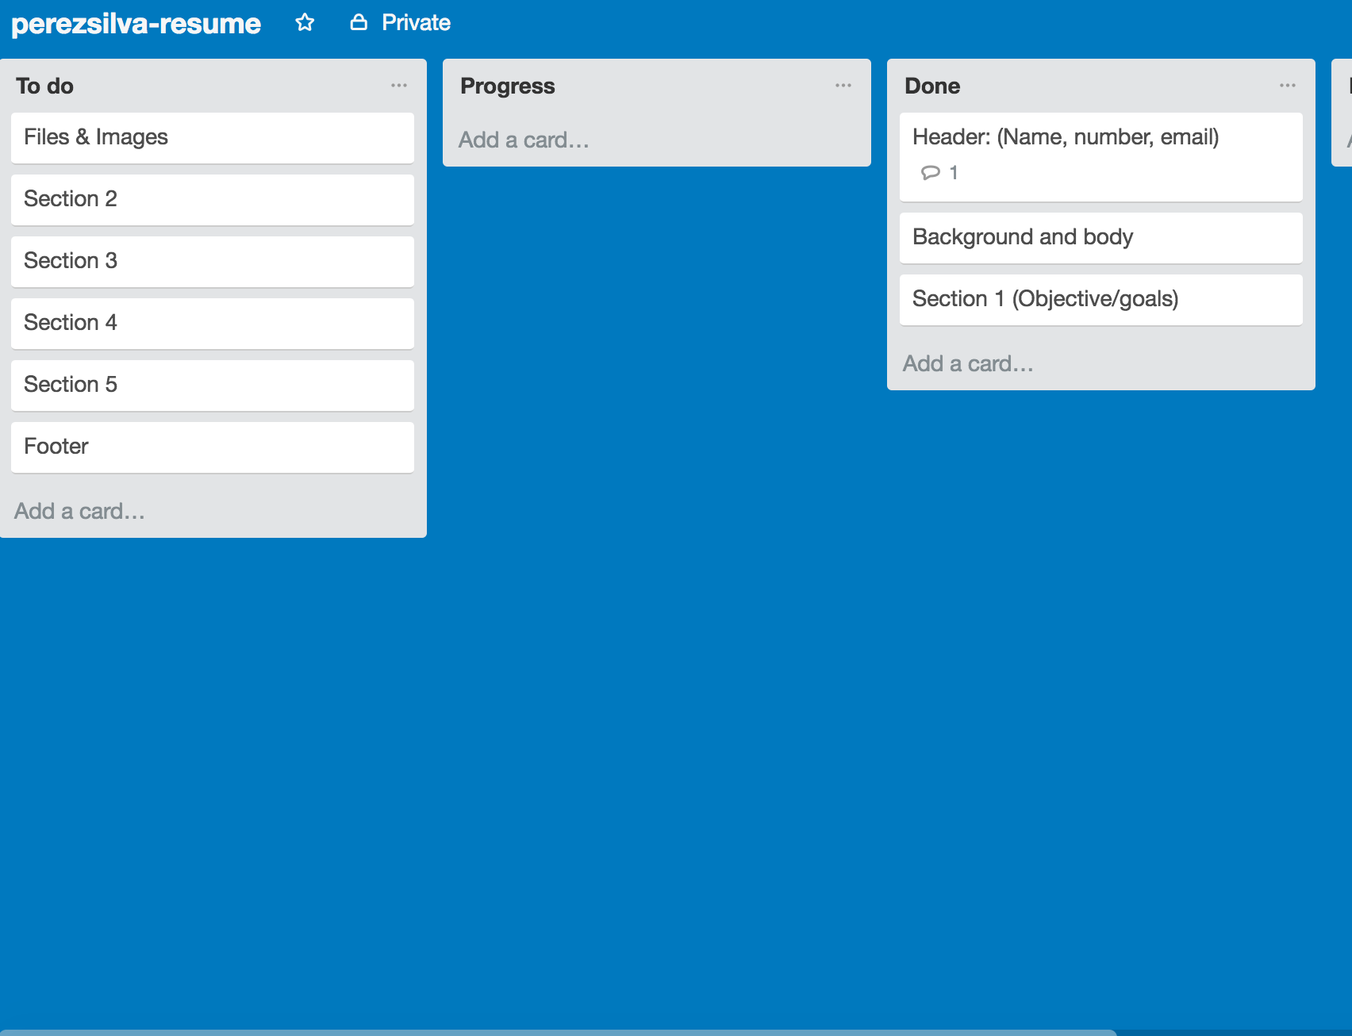

This image shows that I finished my background image and my first section which involved the layout of the section and my objectives and goals.

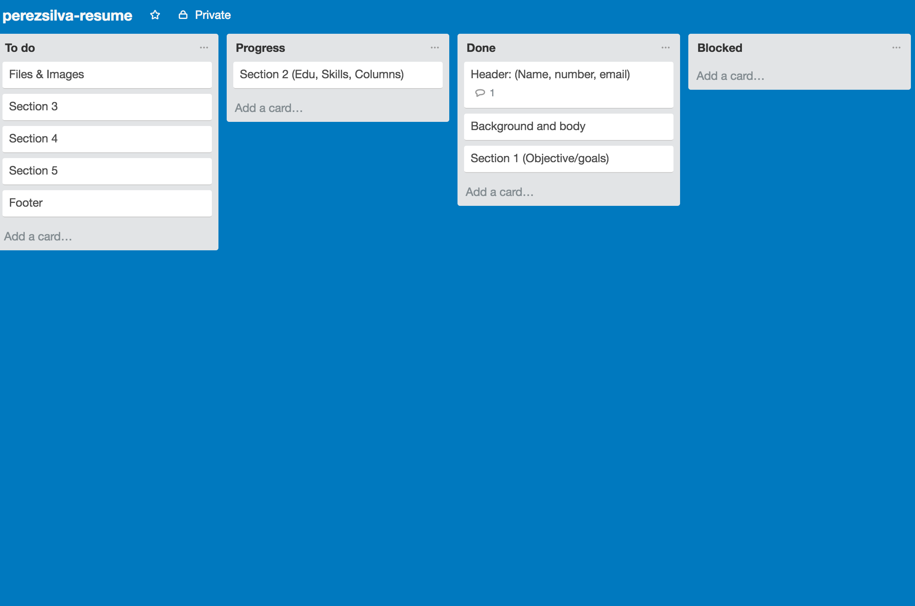

This image shows that I’m making progress in my second section which involves the layout, my education, skills and columns.

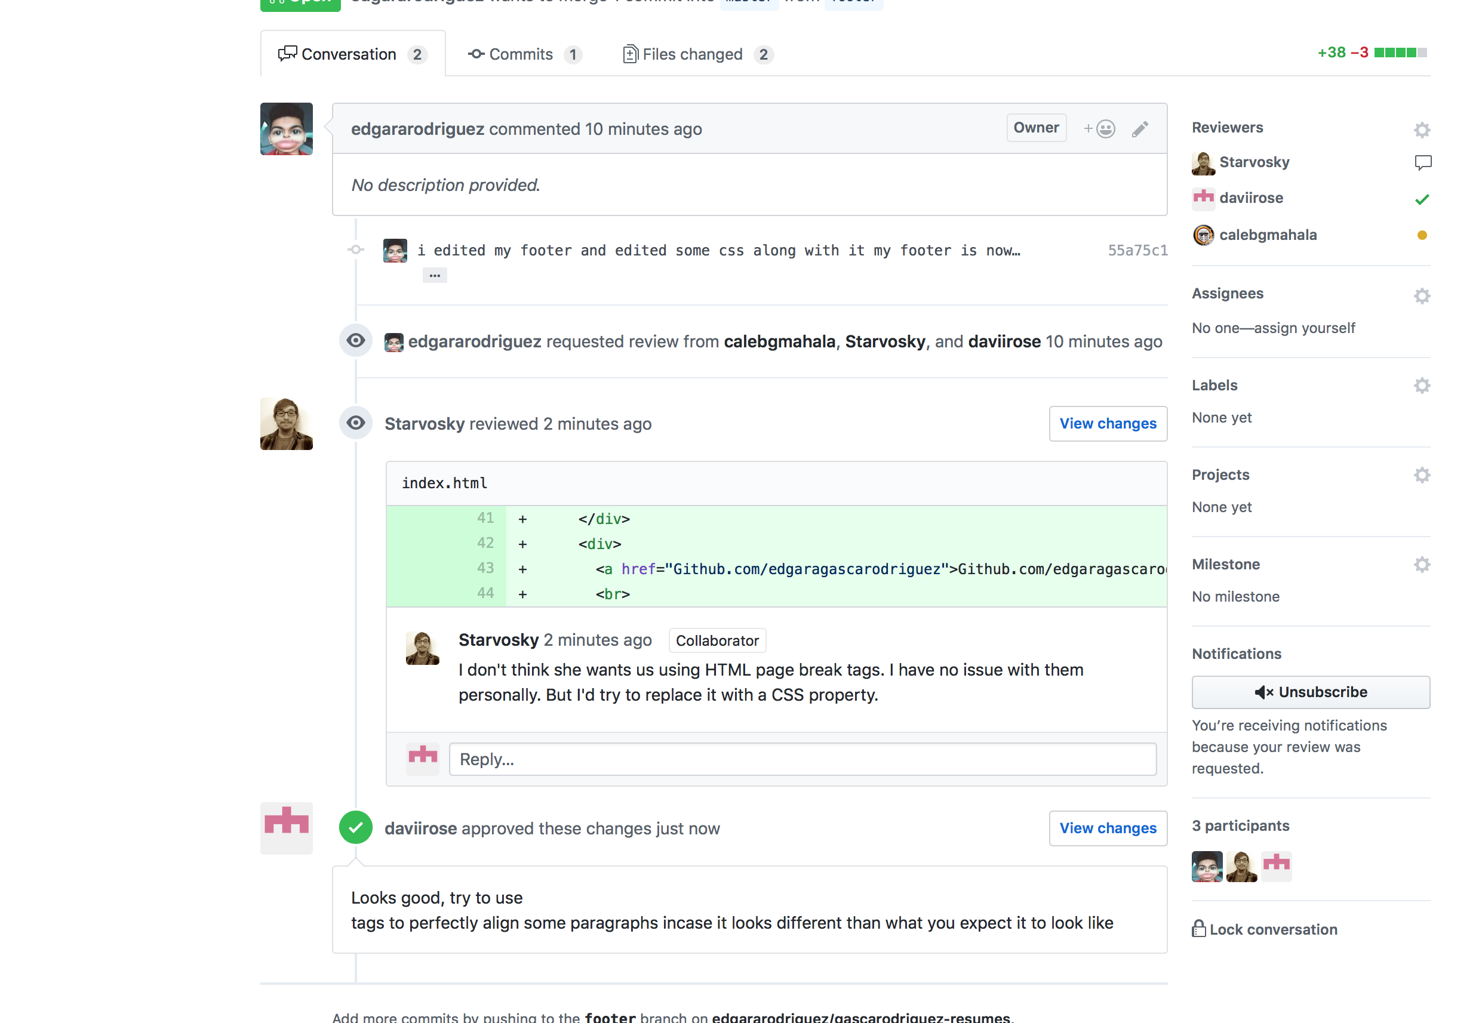

This image shows one of my PR’s, I approved it but gave him some advice in laying out his content better visually.

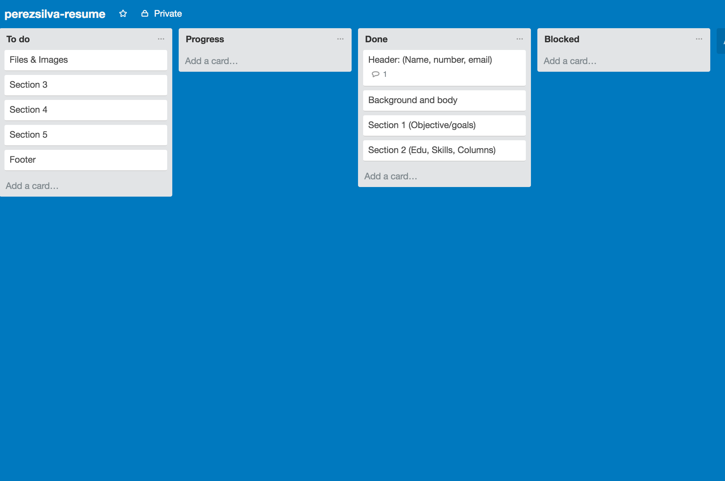

This image shows that I got done with section 2 which involved education, skills and I made a column out of them.

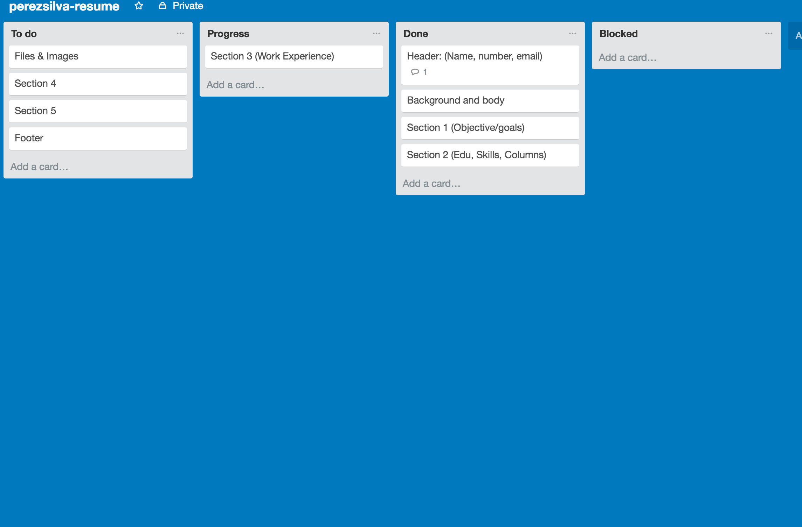

This image shows that I started section three of my resume which is also known as the work experience section.

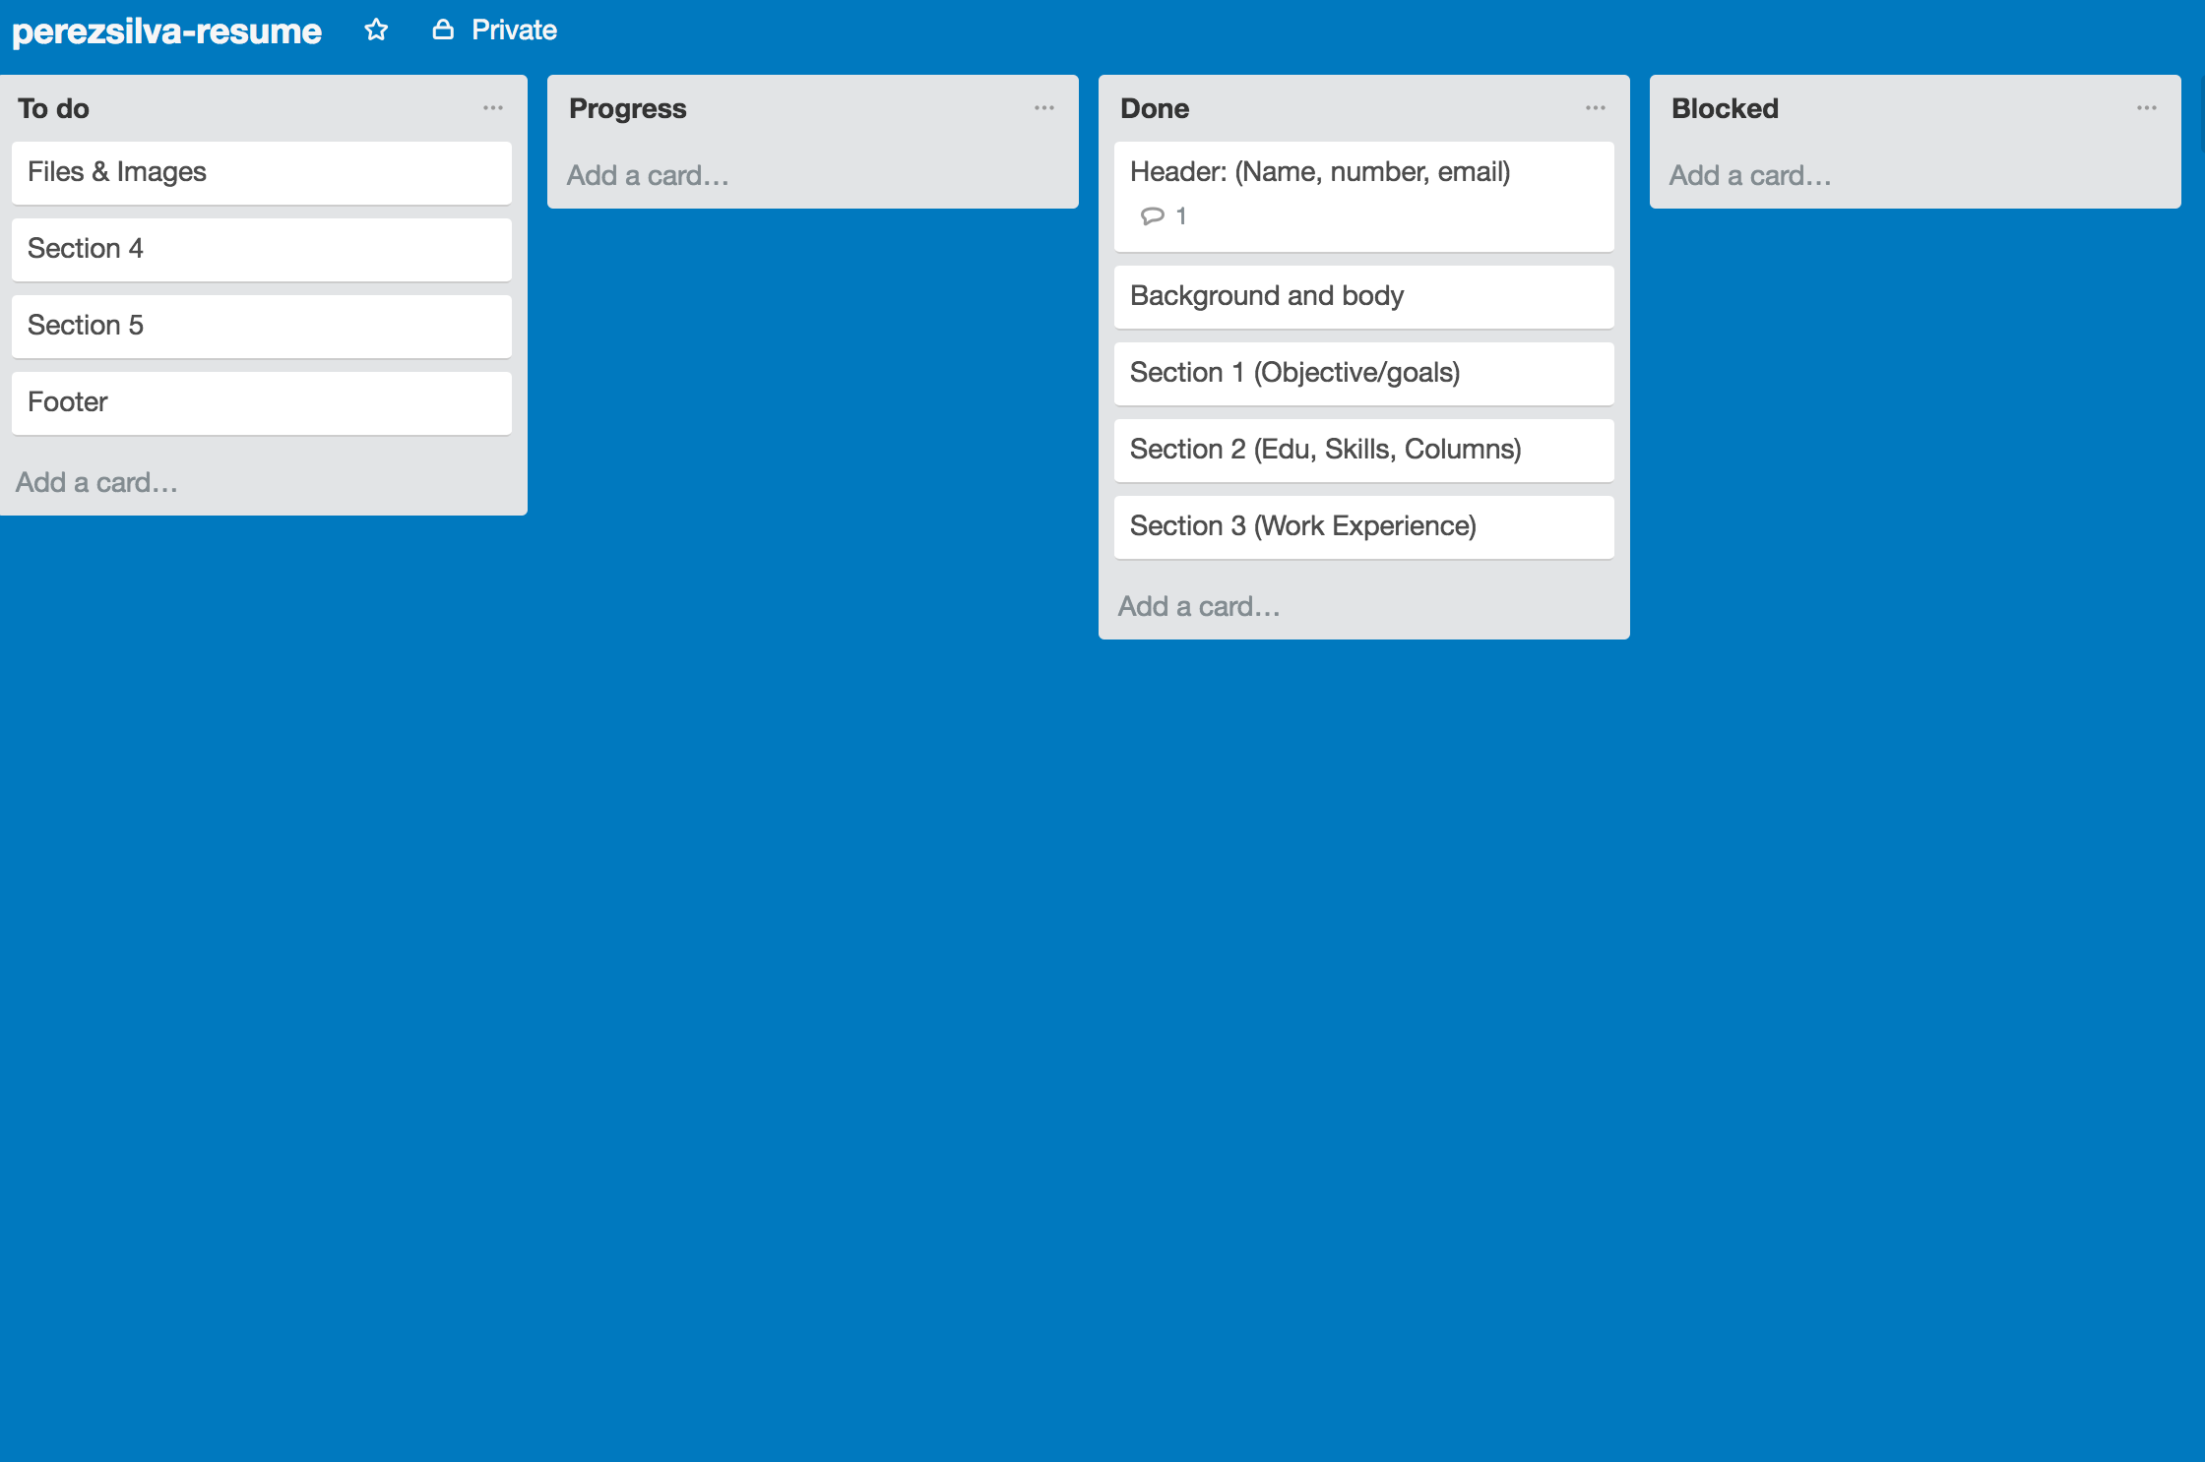

This image shows that I just got done with section three which is the work experience section.

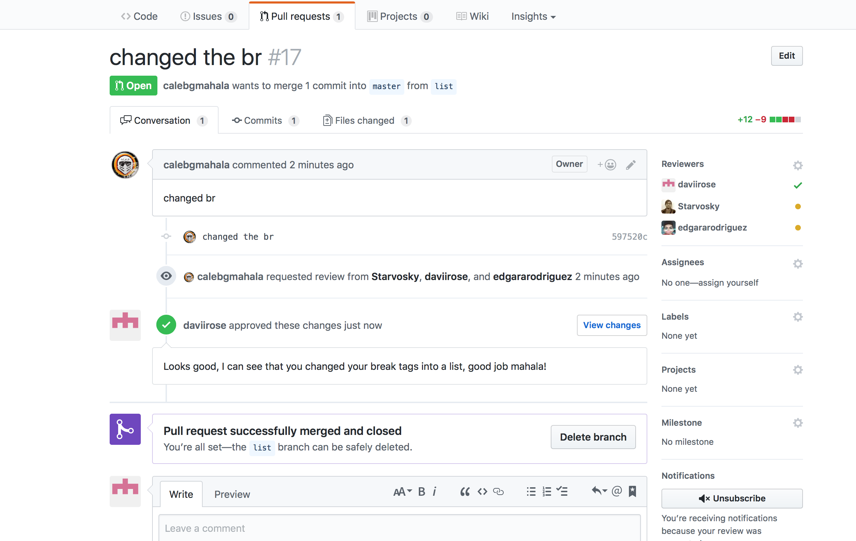

This image shows one of many reviews, simply saw a good changed In one of group members work and congratulated him.

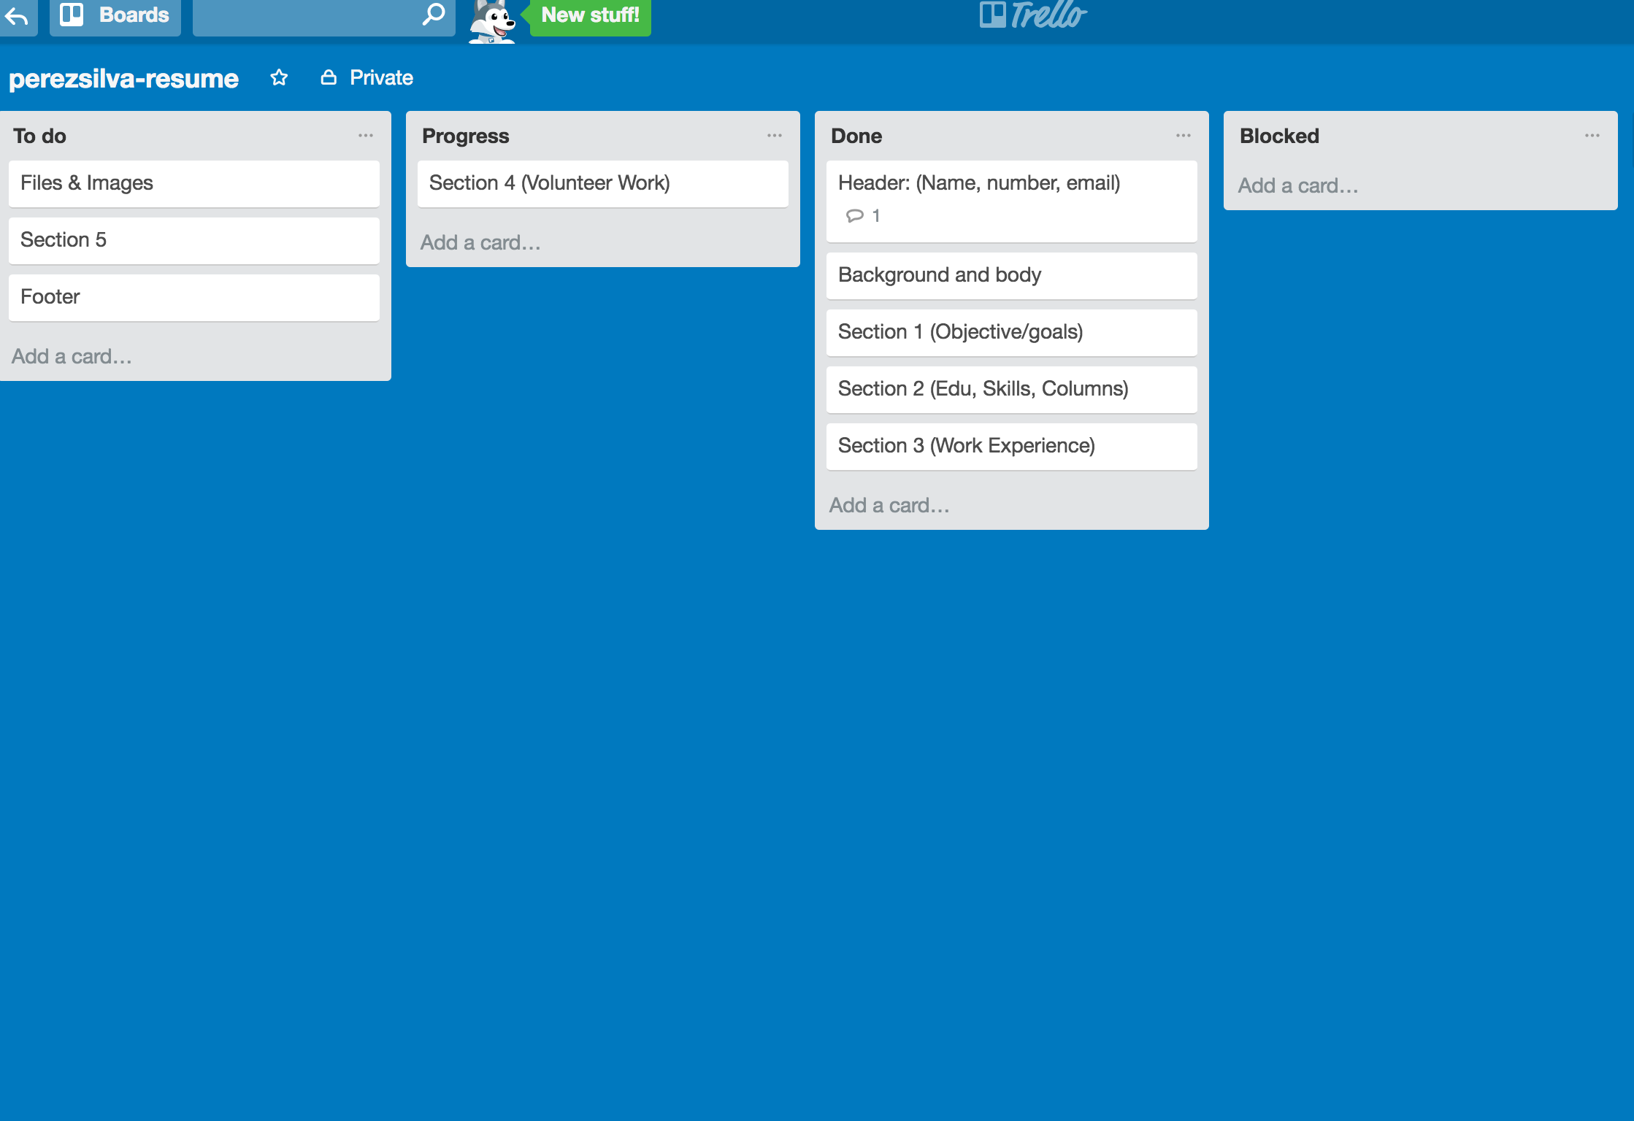

This image shows that I am in progress with section four which is my volunteering work section.

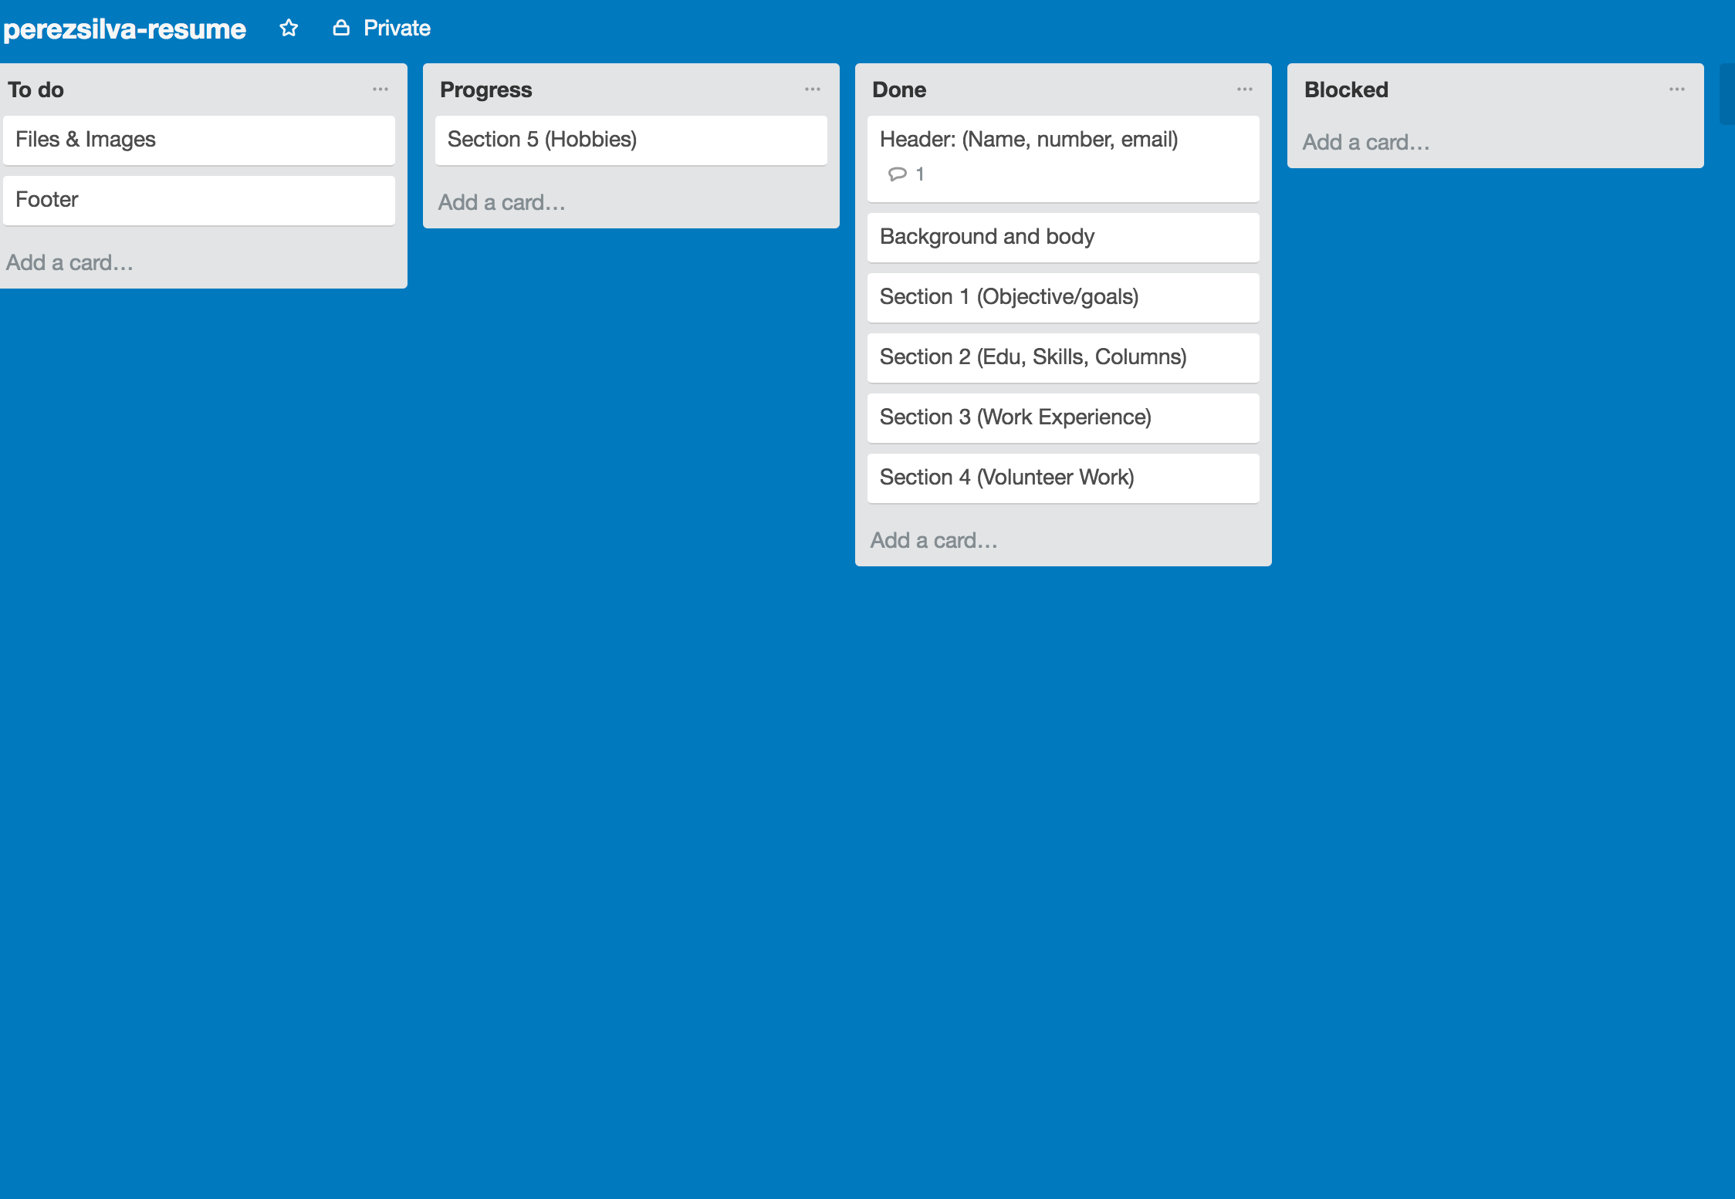

This image shows that I started my hobby section which is section five.

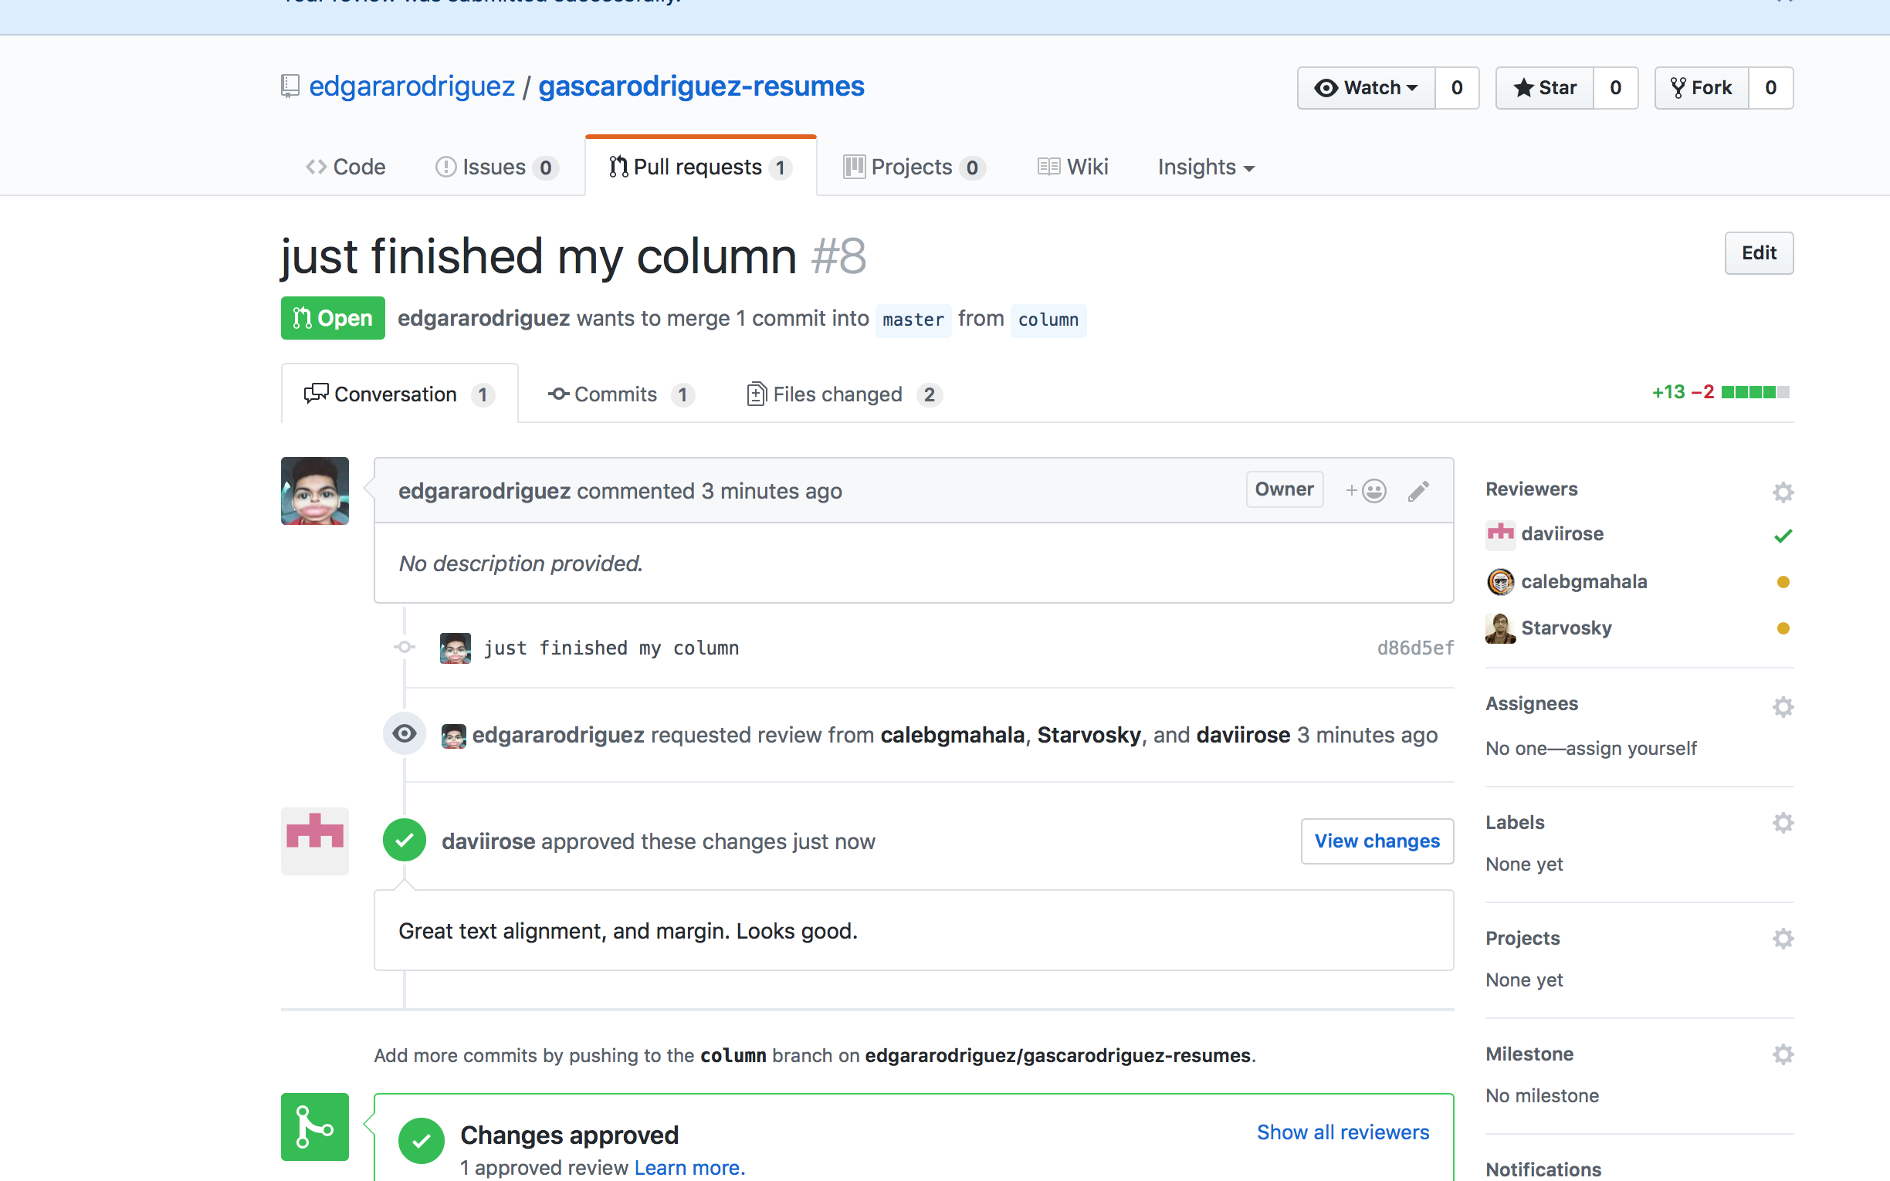

This image shows another PR from me to another group member, I was pleased with what they showed so I approved it right away.

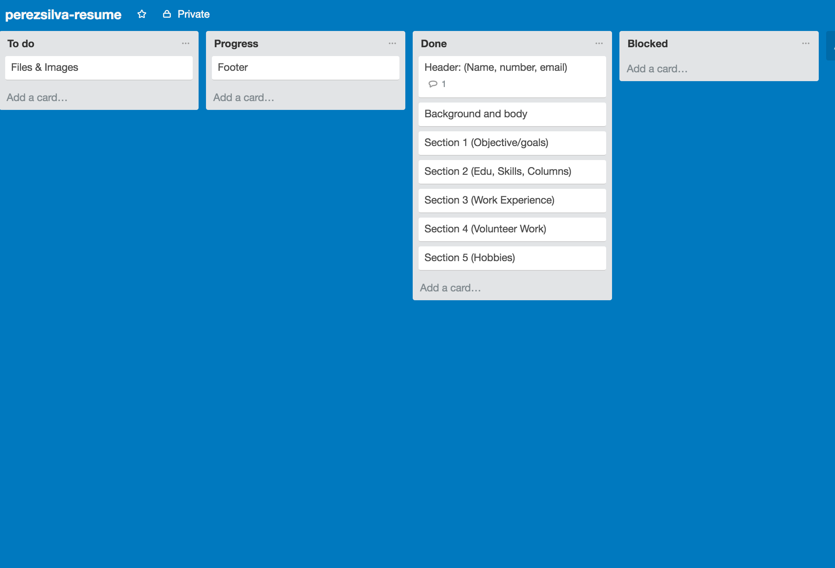

This image shows that I started my footer section, it is similar to the navigation section just align a little differently.

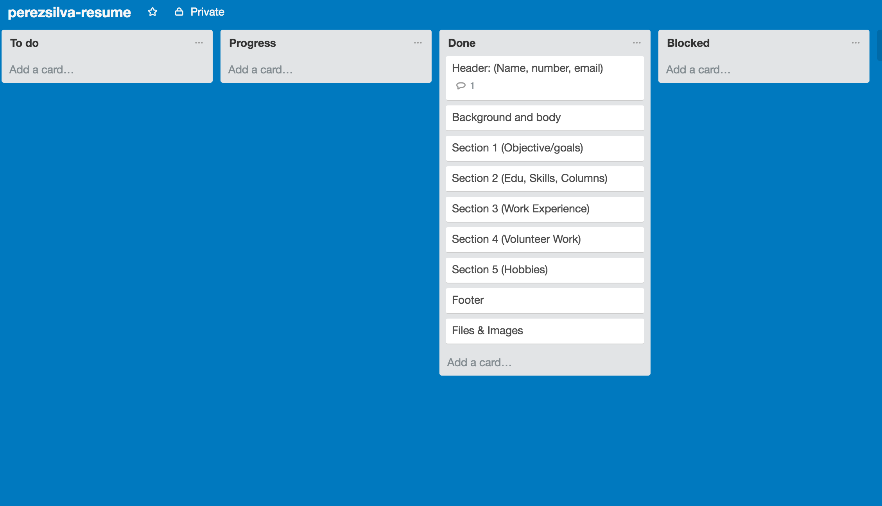

This image shows that I finished the footer and added all the images in one file.